Assignment 6

Part II

1. Check 100 products and Authentication
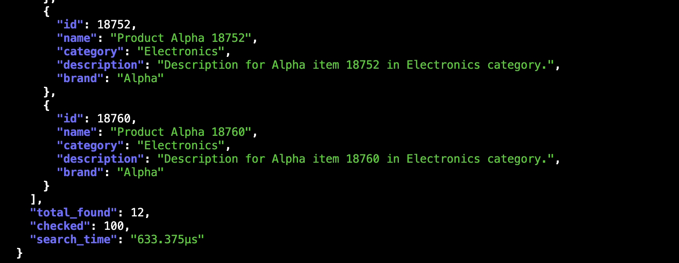

2. Build and run docker locally
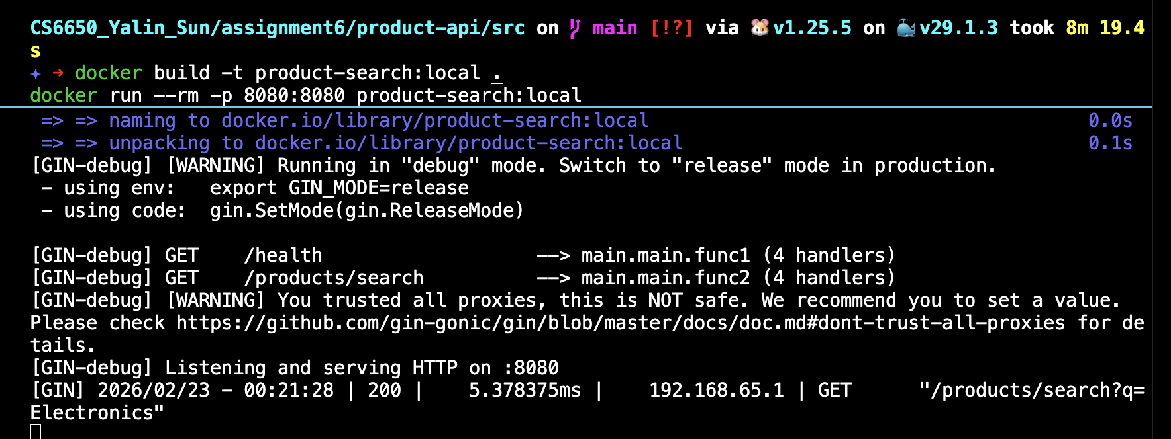

3. Deploy to AWS ECS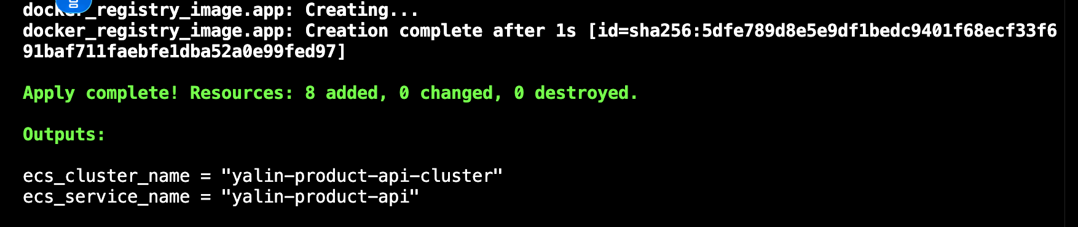

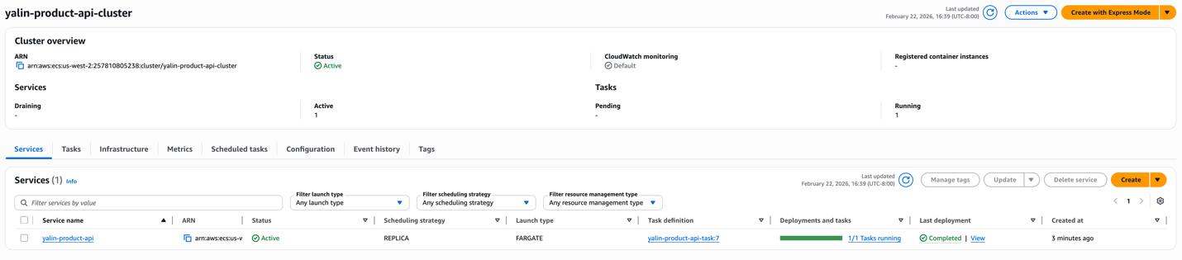

4. Curl to test
curl -H "X-API-Key: test" "http://44.248.46.40:8080/health"
curl -H "X-API-Key: test" "http://44.248.46.40:8080/products/search?q=Electronics" | jq

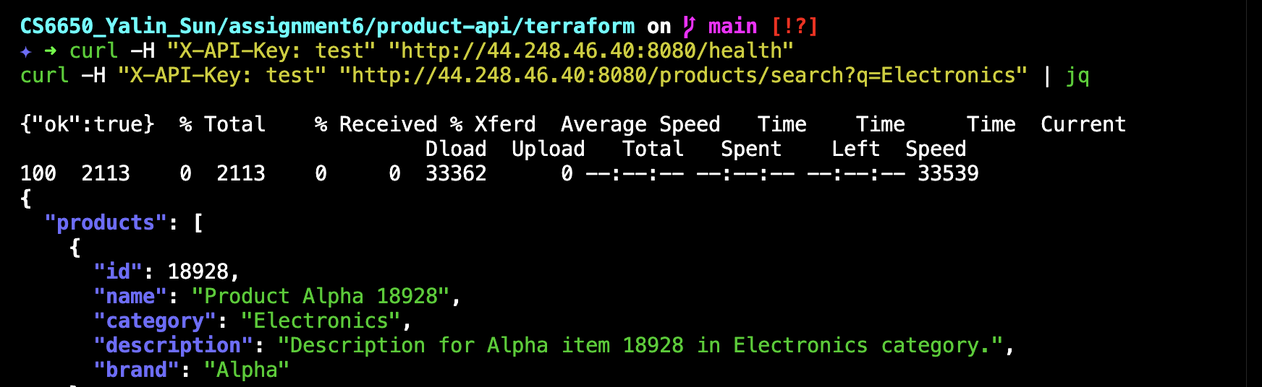
……

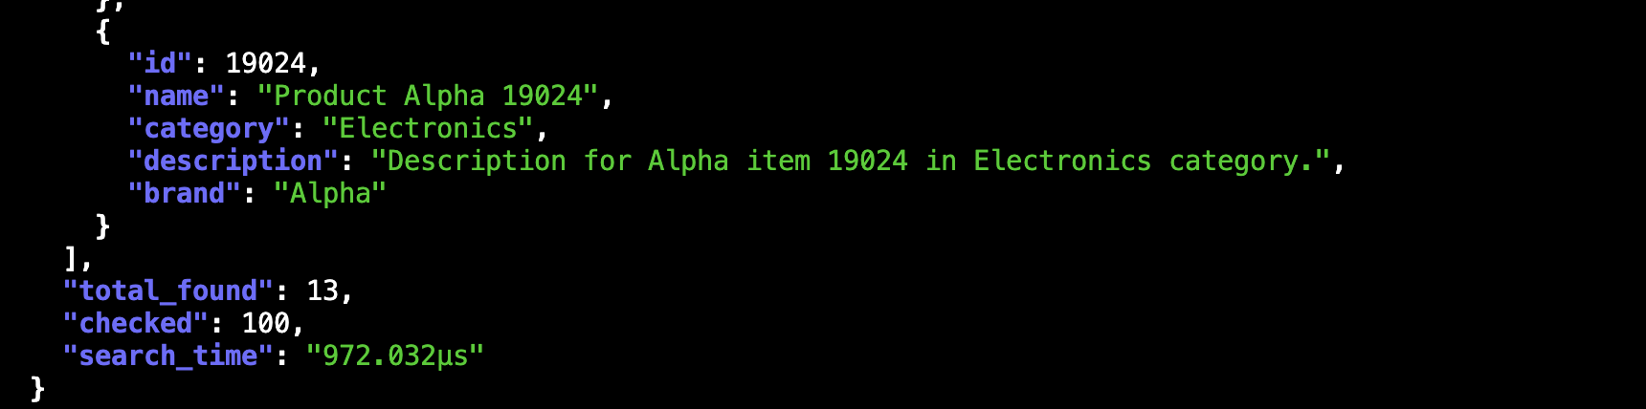

5. Load Testitng Methodology
Two tests were performed:

Test 1: Baseline Load
- Users: 5
- Spawn Rate: 5 users/second
- Run Time: 2 minutes

Test 2: Increased Load (Breaking Point)
- Users: 20
- Spawn Rate: 20 users/second
- Run Time: 3 minutes
During both tests, CloudWatch metrics were monitored for CPU utilization and memory utilization.
6. Results

Test 1: Baseline Performance (5 Users)
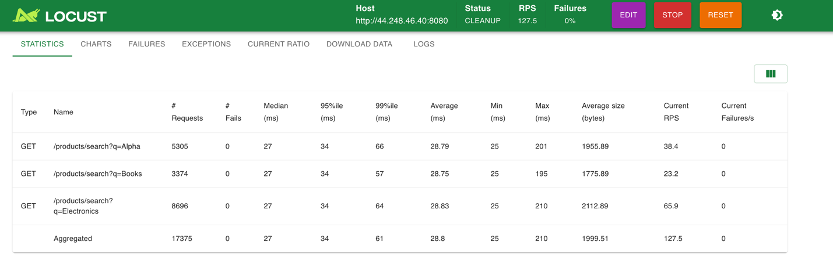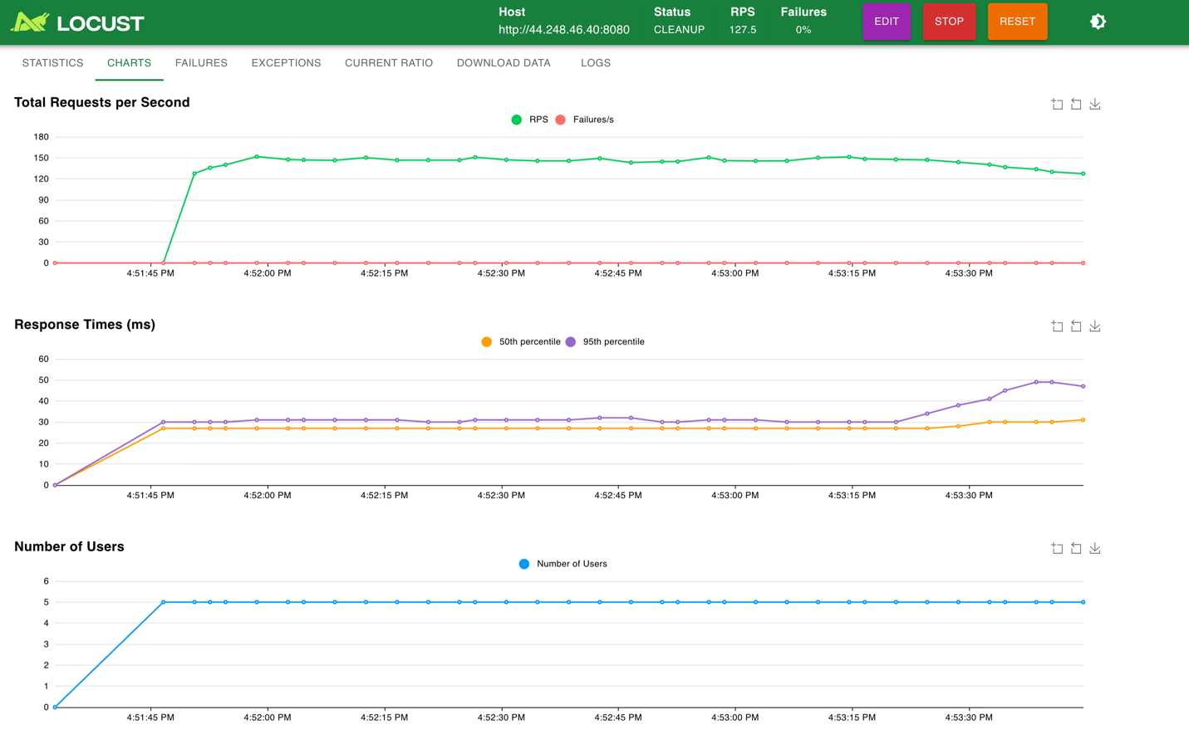
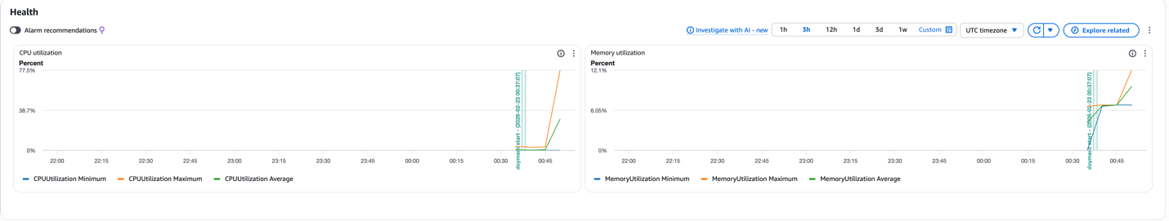
Under a light load of 5 concurrent users, the system demonstrated stable and fast performance:
- Average latency was approximately 28–30 ms.
- 95th percentile latency remained below 35 ms.
- Requests per second (RPS) stabilized around 127.
- Failure rate was 0%.
From CloudWatch metrics:
- CPU utilization increased but remained below saturation (maximum around 70–80%).
- Memory utilization stayed stable at approximately 12%.
This indicates that the system can comfortably handle this load without resource exhaustion.

Test 2: High Load Performance (20 Users)
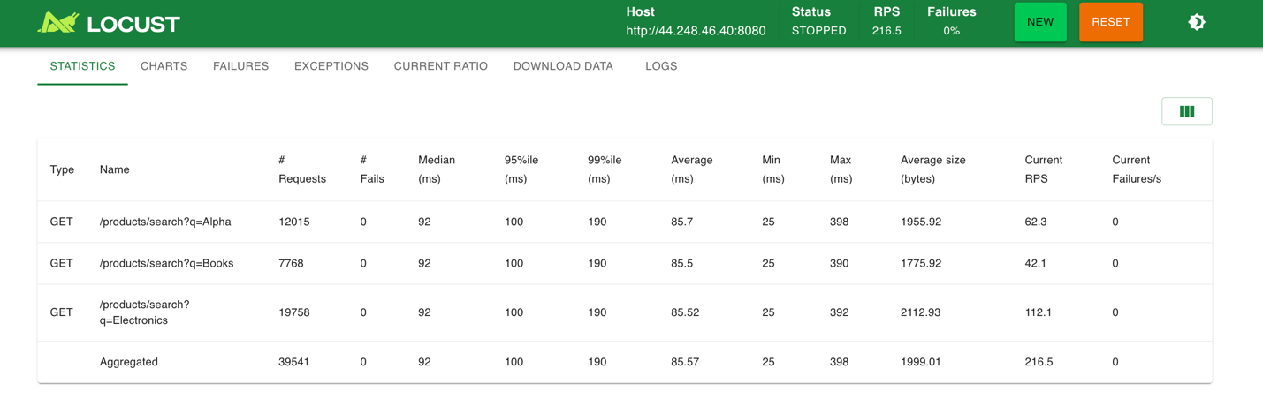
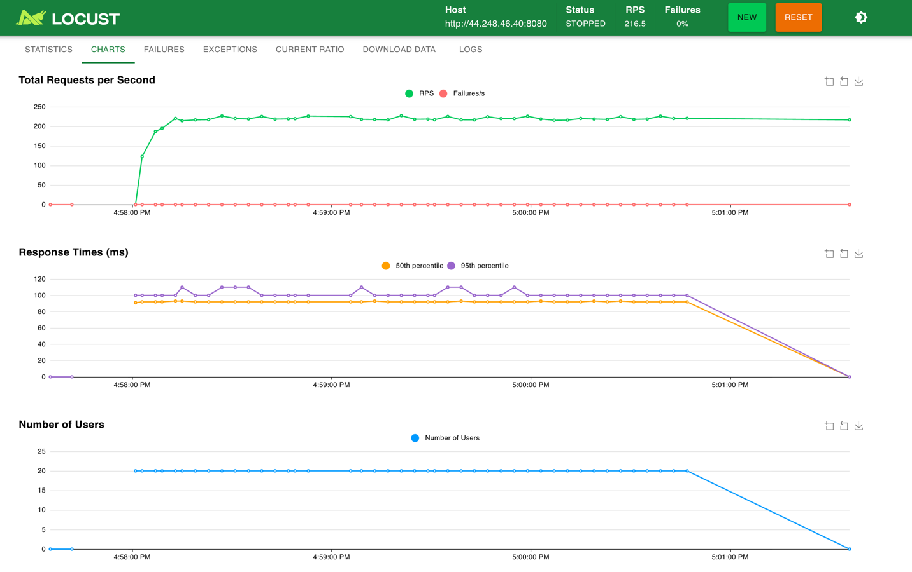
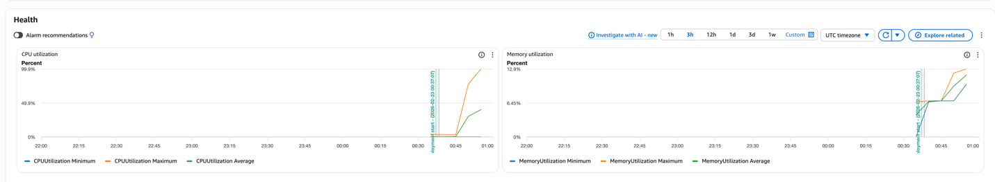

When the number of concurrent users increased to 20, performance degradation became clearly visible:
- Average latency increased to approximately 85 ms (about 3× higher than Test 1).
- 95th percentile latency increased to around 100 ms.
- 99th percentile latency reached approximately 190 ms.
- RPS increased to around 216 but did not scale linearly with the number of users.
- Failure rate remained 0%.
CloudWatch metrics revealed:
- CPU utilization reached nearly 100%, indicating full CPU saturation.
- Memory utilization remained steady at around 12–13%, similar to Test 1.

5. Bottleneck Analysis
The results clearly show that CPU is the primary bottleneck in this system:
- As load increased, CPU utilization rose to nearly 100%, while memory usage remained stable.
- Response times degraded significantly once CPU saturation was reached.
- Throughput (RPS) increased only modestly despite a 4× increase in concurrent users.
Because each request performs a fixed amount of computation and checks exactly 100 products, there is limited opportunity for algorithmic optimization. The observed behavior is consistent with a CPU-bound workload, where increased concurrency leads to CPU contention and request queuing.

6. Scaling vs. Optimization Decision
Based on the collected evidence, performance issues under high load are not caused by inefficient code, but by insufficient compute resources. In this scenario, the appropriate solution is scaling, not optimization.
Potential scaling strategies include:
- Increasing CPU allocation (e.g., from 256 to 512 CPU units).
- Adding more ECS task instances and distributing traffic across them.
Doubling the available CPU would likely reduce request queuing, lower response times, and improve throughput for the same workload.

Part III
product-search-alb-1837533519.us-west-2.elb.amazonaws.com
1. Create Application Load Balancer
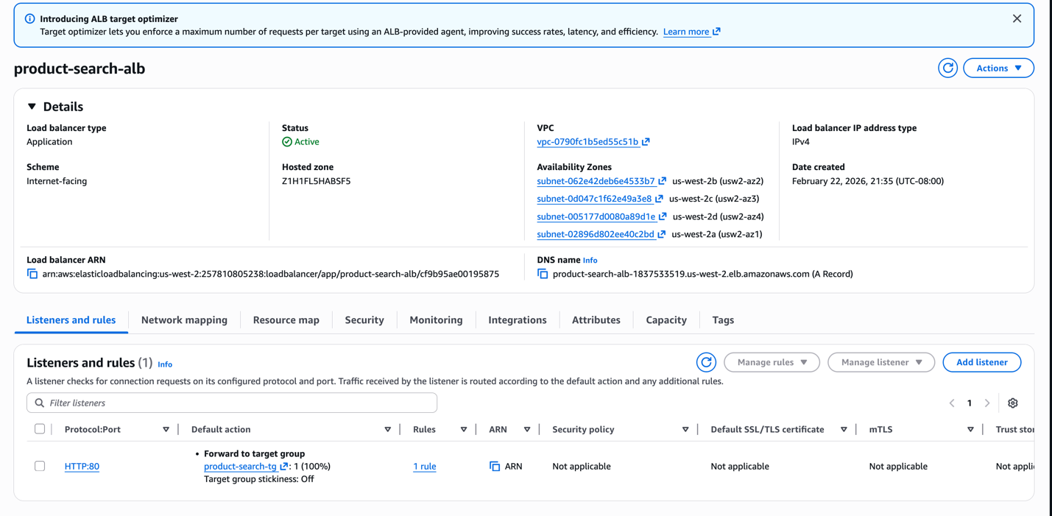
52.24.138.5
2. Connect ALB and Target Group to ECS Service
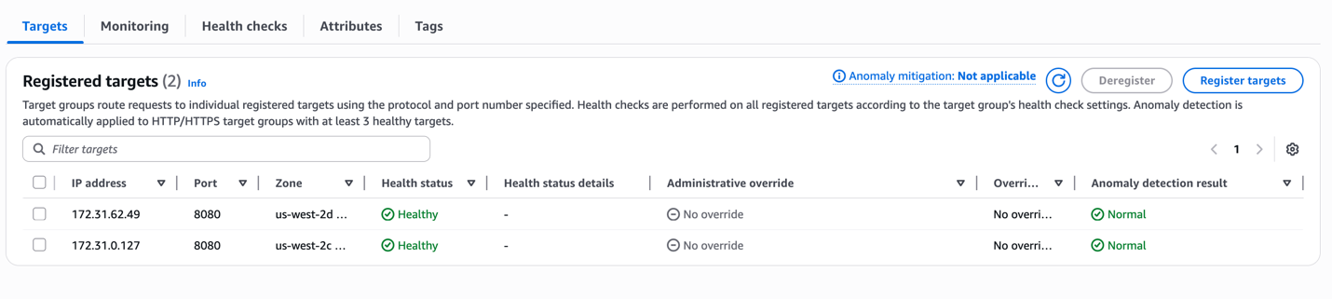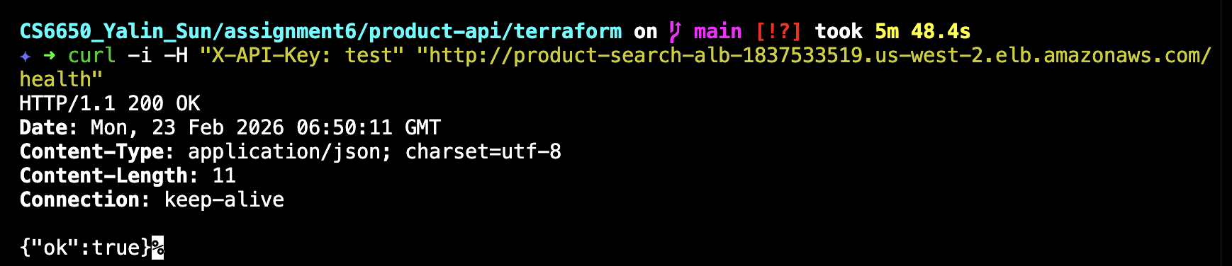

3. Set up Auto Scaling
